Q. what are acids rains ? discuss the causes, consequences and control measures of acid rains.

Answer : Acid rain is rainfall that contains a high amount of acids and has a lower pH than normal rain. It is mainly caused by the presence of Sulphur Dioxide (SO₂) and Nitrogen Oxides (NOₓ) in the atmosphere.

These gases react with water vapour and oxygen in the atmosphere and form Sulphuric Acid (H₂SO₄) and Nitric Acid (HNO₃). These acids then come down to the earth with rain.
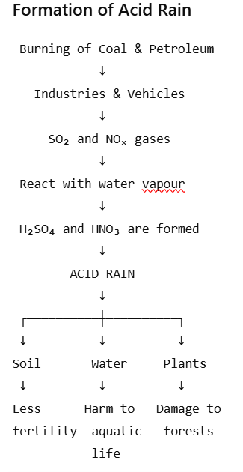
Causes of Acid Rain
- Burning of coal and petroleum in industries and power plants releases SO₂.
- Vehicle emissions release nitrogen oxides (NOₓ).
- Industrial activities release large amounts of harmful gases.
- Burning of fossil fuels for electricity and transportation increases air pollution.
- Natural sources such as volcanic eruptions and forest fires can also release some acid-forming gases.
Consequences / Effects of Acid Rain
- Effect on plants:
Acid rain damages leaves, reduces plant growth and can destroy forests.

- Effect on soil:
It removes useful minerals and nutrients from the soil, making it less fertile.

- Effect on aquatic life:
Acid rain makes lakes and rivers acidic. It can kill fish
and other aquatic organisms.

4. Effect on buildings and monuments:
It damages metals, paints, buildings and marble
monuments. Historical monuments can slowly lose
their surface.

5. Effect on human health:
Acid rain itself does not usually directly burn the skin,
but the SO₂ and NOₓ pollution that causes it can
contribute to respiratory problems.

Control Measures

- Use clean and renewable energy such as solar and
wind energy.
- Reduce the use of coal and other fossil fuels.
- Use low-sulphur fuels in industries and vehicles.
- Install scrubbers in industrial chimneys to remove
SO₂.
- Use catalytic converters in vehicles to reduce
harmful gases.
- Promote public transport, carpooling and electric
vehicles.
- Plant more trees and protect forests.
- Follow strict air-pollution control laws.

